**CSC 425 - Final Proejct - Technical Analysis**

**Time Series Analysis on**

**China Resources Pharmaceuticals (Shanghai Stock Exchange No. 600062)**

Zhenyang Lu

DATA from Yahoo-Finance/China and Tongdaxin Financial Data Center.

**1.0 EXPERIMENT OBJECTIVE**

Perform time series, 5-year data, on the stock to assist investment.

**2.0 Assumption**

Assumption of data analysis is very important to financial time series analysis. How you choose your data set is crucial to the accuracy of your report. In our report, I will perform analysis based on Dataset for long-term comes from year 2008 to last week, this is also the usual time interval for the computation of stock's Beta.

Another important assumption is that the main variable that is analyzed is the stock's simple return, not its log return, since Chinese stock market has an upper and lower bound for daily price volatility of 10% of yesterday's closing price. In this case, the difference between log return and simple return is relatively small.

**3.0 Analysis**

**3.1 Exploratory analysis of the data.**

Time plot of the stock performance and return is like

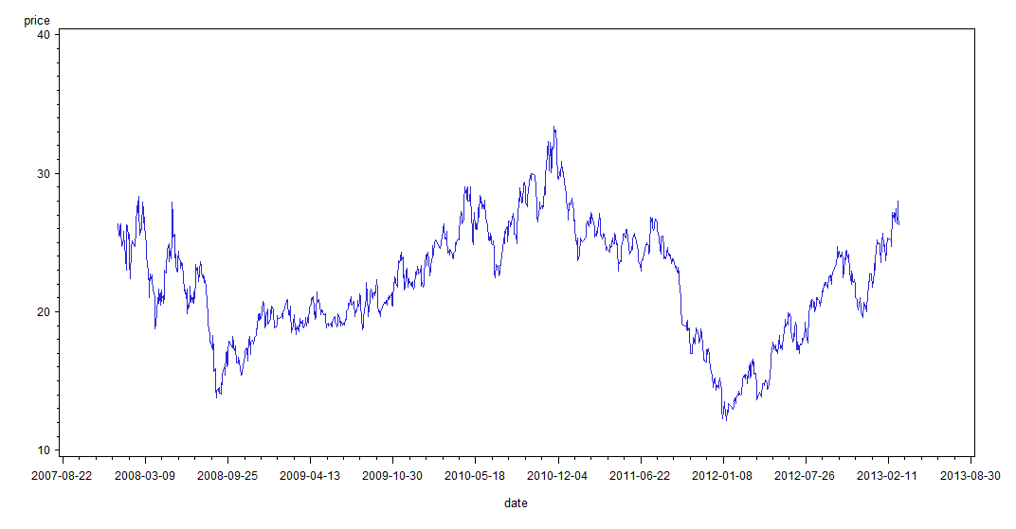

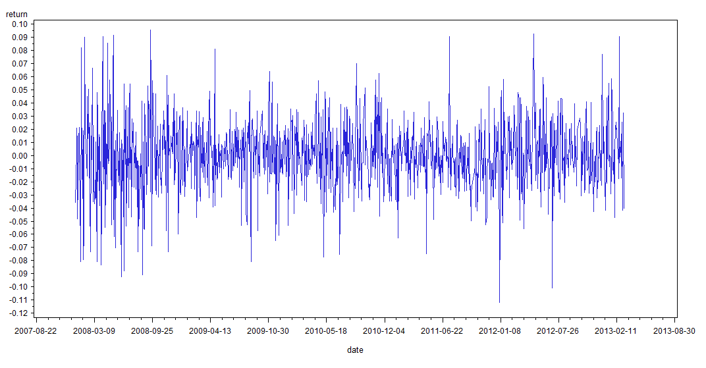

We start from ACF analysis. First, we make sure the data is time series correlated. Actually it is correlated as we expect. ACF suggests a AR(2) model.

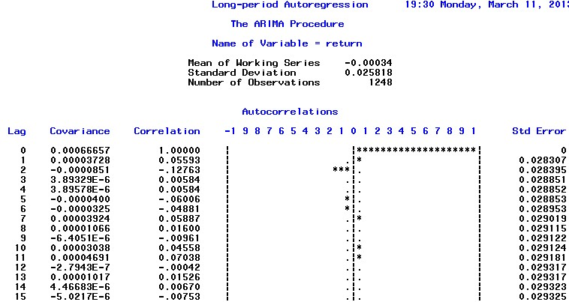

Second, we want to detect if there is ARCH effect (we detect ARCH effect on short-period, too, and it does not possess the trait). The following two pictures show the PACF of absolute simple return and squared return. They accept the conclusion that the long-term-period dataset has ARCH effect.

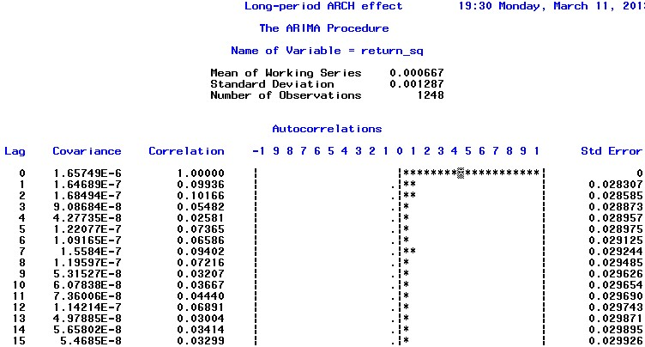

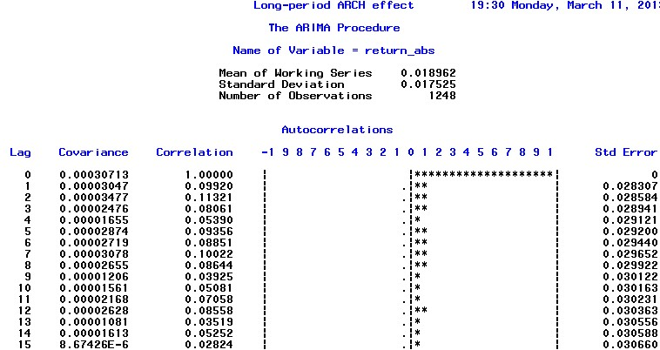

ARCH effect enables us to use GARCH model to capture the dependence of variance.

**3.2 Model fitting**

Next important step, we want to decide if we should use EGARCH or GARCH. We run EGARCH model on the dataset and find a significant EGARCH coefficient (we want to use EGARCH not IGARCH for person preference).

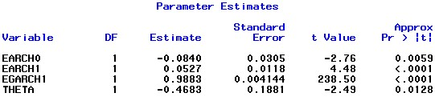

Consequently, EGARCH model is our choice. We start from EGARCH (2, 2) and finally reach an EGARCH (1, 1) model, since it has the most minimum AIC and best residuals as you could see later.

However, an EGARCH model alone cannot capture all the relationship between the data, since the PACF of absolute return residual is significant. Therefore, we have to apply AR model together with EGARCH model to completely understand the relationship. We start from AR(5) as indicated by the PACF of return above and get AR(2) finally. From the picture below, we could see that EGARCH coefficient is also significant.

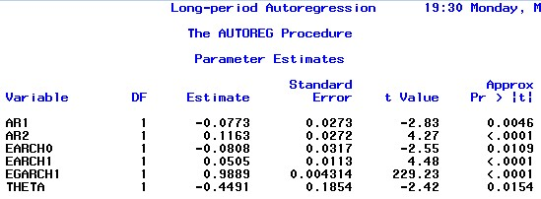

Thus, our model is



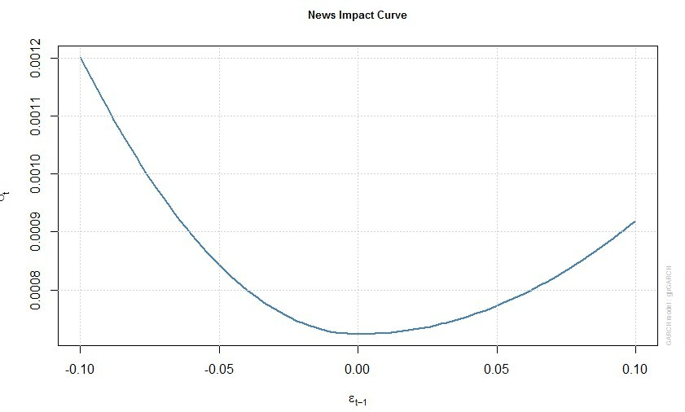

From this picture, we could clearly see the leverage effect. The price return of negative 10% has a volatility that is larger than that of positive 10% return.

**3.3 Residual analysis and model diagnostics.**

Our final step to make it rounded is to check the residuals.

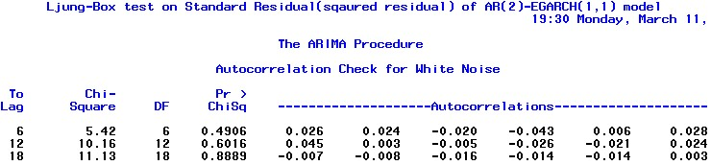

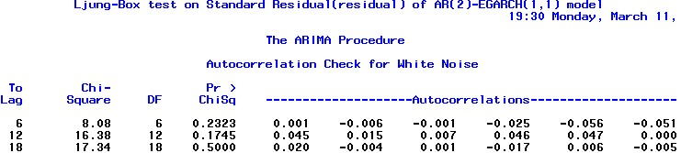

We could see that both the residual and squared residual are white noise. For normality test, the residuals show fat tails on both sides, while it is still a normal distribution.

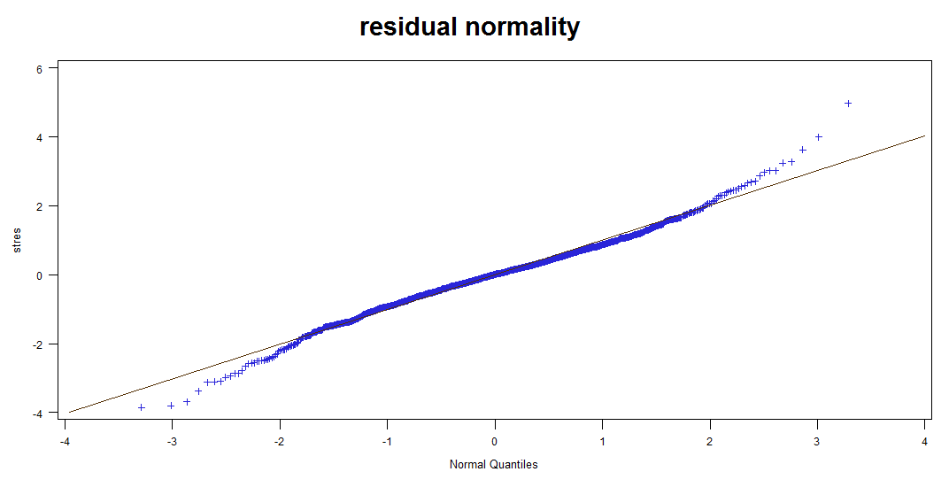

**3.5 Forecast analysis**

Forecast of the model gives us,

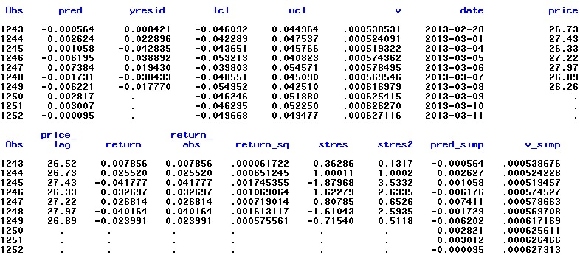

A picture gives a clear view of the forecast. The light grey lines are 95% confidence interval and the black 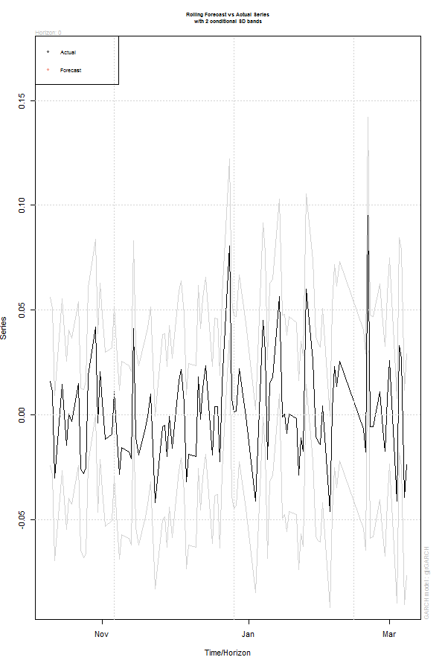

Line is the predicted valus.

From this point, we could conclude that the return estimate of it is bad, while it is still within the 95% confidence interval.

**3.6 Conclusion on long-term analysis**

Since GARCH model captures the dependence of variance, its main application in our analysis is to manage the risk. Take an example, the forecast made by our AR (2)-EGARCH(1,1) for next trading day is [-0.047,0.052], assuming 95% confidence. That means based on the previous 5-year experience of the stock, we could say with 95% confidence that the next day's price return is with -4.7% and +5.2%. If we want to analyze the risk of a portfolio, we just need to plug in the number for each stock in the portfolio, and get the weighted average volatility. Actual price return in the consecutive three days is total -1.4% while the predicted value is only 0.58%, that is mainly because the market does not perform well. Our model does a really good work on volatility forecast, but bad on return estimation.

**4.0 Drawback and comments**

First, we have to update our model frequently in order to gain the accurate forecast, since the AR (2) model's forecast or return will converge to mean the dataset and the EGARCH model's forecast will converge to variance of the dataset.

Second, our residual analysis on AR-EGARCH model maybe indicates that there is seasonal effect inside. As previously discussed, the Ljung-Box test on standard residuals of EGARCH model gives us result like



Some correlation coefficients are relatively high. We could also see from PACF of standard residuals,

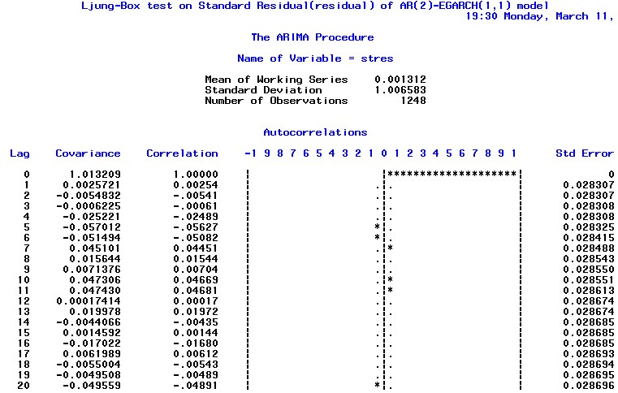

I doubt there is relationship, ACF of lag5, 6 and lag10, 11 are significant, that we have not captured by the model. This is maybe because there are five trading days in a week and speculative investors typically that avoid bad news at weekend would sell their stocks at Friday and buy them back at the beginning of week, causing the correlation of lag 5 higher. However, at this time we are not able to do a SARIMA-EGARCH model.

**5.0 Appendix**

For additional information about Appendix, please see attached files in the folder.

1. SAS output

2. SAS code

3. Raw data

4. Nontechnical report

6. PPT for presentation